**APPENDIX II: USE /MISUSE CASE DIAGRAM AND DOCUMENTATION**

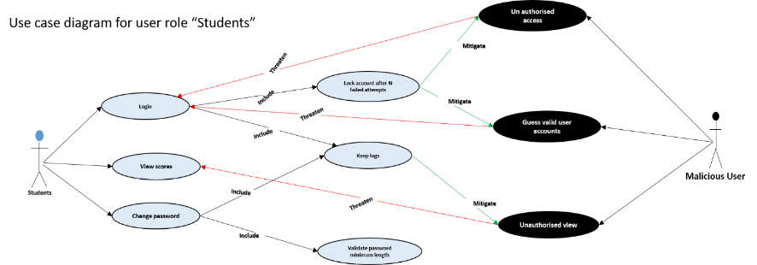

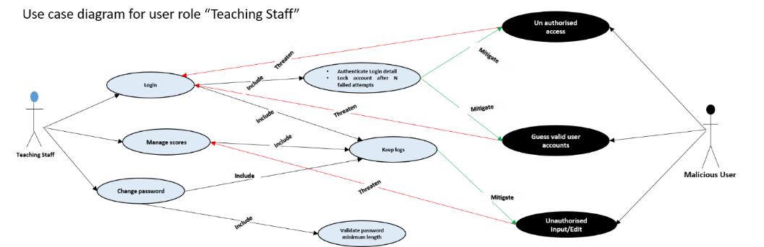

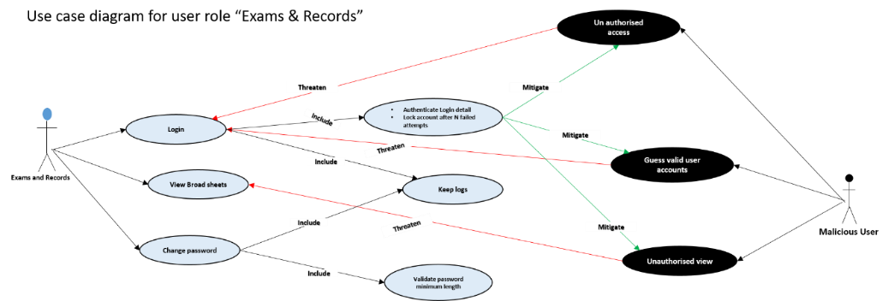

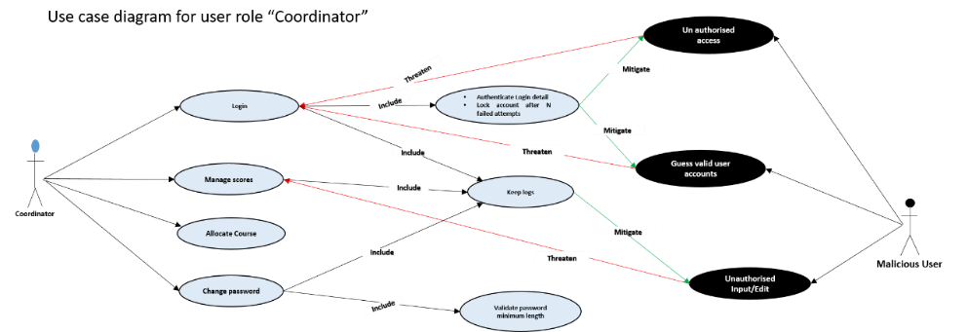

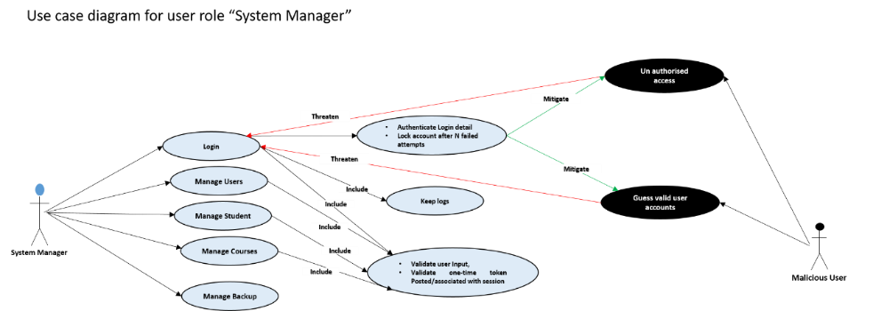

**Use case documentation**

**UC1 Login to account**

Enable users to login into the application to access certain menus.

**Basic flow of events**

The use case begins when the system present user a login form.

|  |  |
| --- | --- |
| System: | Ensures that users enter username and password. **(A1)**  Verify user input. **(A2)** |
| User: | Enter username and password. **(A3)** |
| System: | Verifies the username and password entered is correct. **(A4)**  Determine the type of user and Display the user Dashboard and menus  Keep logs |

**Alternative flows**

**A1-Username and password field cannot be empty**

The user submit an empty field, both username and password field must be empty.

|  |  |
| --- | --- |
| System: | Prompt the user that username and password field cannot be empty |

**A2 - Unwanted character entered**

The system cannot allow unwanted character. User must have entered unwanted character.

|  |  |
| --- | --- |
| System: | Prompt the user that unwanted characters are not allowed. |

**A3 – Lock account**

System detect that login details are entered more than the required number of times

|  |  |
| --- | --- |
| System: | Lock account after N failed attempts |

**A4 – Incorrect username and password**

System verifies the login details to be incorrect

|  |  |
| --- | --- |
| System: | Display incorrect username and password. |

**UC2 Manage users**

Enable system manager (user) to add new user, view and edit user detail.

**Basic flow of events**

The use case begin when the user logged in successfully.

|  |  |
| --- | --- |
| System: | Display user dashboard and menu options. e.g. “Manage user” menu |
| System manager: | Click on the manage user menu. |
| System: | Display the sub menu options for managing user, these are: Add, edit, and view user |
| System manager: | Selects one of the sub menu to Add user. **(A1, A2)** |
| System: | Present user registration form for user to input full name, username, number, select department, select user type with submit button. |
| System manager: | Enter name, username, number, select department, select user type and click on submit button. **(A3)** |
| System: | Ensure no field is left empty. **(A4)**  Verify user input. **(A5)**  Add the new user. **(A6)** |

**Alternative flows**

**A1 – Edit user**

**A2 – View user**

**A3 - Session Timeout**

The system detects a session timeout

System: Displays timed out message and/or re-directs to login page.

**A4 – Empty fields not allowed**

System: detect empty fields submitted

System: Prompt/Display all field are required, no field can be left empty

**A5 – Unwanted input (character)**

System detect that special character are inputted

System: Special Characters not allowed

**A6 – User registration successful**

System: prompt/display user registration successful

**UC3 Manage Students**

Enable system manager (user) to add, edit and view student records.

**Basic flow of events**

The use case begin when the user logged in successfully”.

|  |  |
| --- | --- |
| System: | Display user dashboard and menu options. e.g. “Manage students” menu. |
| System manager: | Click on the manage students menu |
| System: | Display the sub menu option for managing student record, These are: Add, Edit, and view student. |
| System manager: | Select one of the sub menus to add new student. **(A1, A2)** |
| System: | Present student registration form for user to enter student name, number, department, gender, session with a submit button. |
| System manager: | Enter student name, number, department, session, gender then click on submit button. **(A3)** |
| System: | Ensure no field is left empty. **(A4)**  Verify user input. **(A5)**  Register and Create account for student**. (A6)** |

**Alternative flows**

**A1 – Edit student**

**A2 – View student**

**A3 - Session Timeout**

The system detects a session timeout

System: Displays timed out message and/or re-directs to login page.

**A4 – Empty fields not allowed**

System: detect empty fields submitted

System: Prompt/Display all field are required, no field can be left empty

**A5 – Unwanted input (character)**

System detect that special character are inputted

System: Special Characters not allowed

**A6 – student registration successful**

System: prompt/display students registration successful

**UC4 Manage courses**

Enable system manager (user) to add, edit and view Courses.

**Basic flow of events**

The use case begin when the user logged in successfully.

|  |  |
| --- | --- |
| System: | Display user dashboard and menu options. e.g. “manage courses” menu. |
| System manager: | Click on the manage courses menu |
| System: | Display the sub menu option for managing courses, These are: Add, Edit, and view courses. |
| System manager: | Select one of the sub menus to add new course. **(A1, A2)** |
| System: | Present course registration form for user to enter course title, code, department, unit, semester, session with a submit button. |
| System manager: | Enter course title, code, department, unit, semester, session, then click on submit. **(A3)** |
| System: | Ensure no field is left empty. **(A4)**  Verify user input. **(A5)**  Register courses **(A6)** |

**Alternative flows**

**A1 – Edit courses**

**A2 – View courses**

**A3 - Session Timeout**

The system detects a session timeout

System: Displays timed out message and/or re-directs to login page.

**A4 – Empty field not allowed**

System: detect empty fields submitted

System: Prompt/Display all field are required, no field can be left empty

**A5 – Unwanted input (character)**

System detect that special character are inputted

System: Special Characters not allowed

**A6 – student registration successful**

System: prompt/display course registration successful

**UC5 manage backups**

Enable system manager (user) create backup and import backup

**Basic flow of events**

The use case begin when the user logged in successfully”.

|  |  |
| --- | --- |
| System: | Display user dashboard and menu options. e.g. “manage backup” menu. |
| System manager : | Click on the “manage backup” menu |
| System: | Display the sub menu option for managing backup, these are create backup and import backup |
| System manager: | Select the sub menu option to create backup. **(A1)** |
| System: | Create Backup. **(A2)** |

**Alternative flow**

**A1 – Import Backup**

**A2 – Backup created**

System: prompt/Display backup created successfully.

**UC6 Manage results**

Enable coordinator (user) to input/import, edit, and view results.

**Basic flow of events**

The use case begin when the user logged in successfully.

|  |  |
| --- | --- |
| System: | Display user dashboard and menu options. e.g. “manage result” menu. |
| Coordinator: | Click on the menu “manage result”. |
| System: | Display the submenu option to manage result, these are input/import result, Edit result, input CO, View result |
| Coordinator: | Select the option Import result. **(A1, A2, A3)** |
| System: | Present the form to for user to select programme, session and semester, with a submit button |
| Coordinator: | Select programme, session and semester, then click on submit. |
| System: | Ensure programme, session and semester is chosen. **(A4)**  Display form to select course code, select file to import with submit button |
| Coordinator: | Select course code, select file to import, then click on submit button. **(A5)** |
| System: | Ensure course code and file to import is chosen. **(A6, A7)**  Import records. **(A8)**  Keep logs |

**Alternative flows**

**A1 – Edit result**

**A2 – Input Carry - Over Result**

**A3 – View Results**

**A4 – No empty field is allowed**

System detect that empty files submitted

System: Prompt/display empty fields cannot be submitted.

**A5 - Session Timeout**

The system detects a session timeout

System: Displays timed out message and/or re-directs to login page.

**A6 – No empty field is allowed**

System detect that empty files submitted

System: Prompt/display empty fields cannot be submitted.

**A7 – file chosen must be in “.csv” format**

System detect file chosen is not “.csv” file

System: Display/prompt incorrect file format

**A8 – records imported**

**UC7 Import student scores**

Enable Teaching staff (user) to import students score

**Basic flow of events**

The use case begun when the user logged in successfully.

|  |  |
| --- | --- |
| System: | Display user dashboard and menu options. e.g. menu “import score” |
| Teaching staff: | Click on the menu “import score”. |
| System: | Present a form for user to select course code and choose a file to import with submit button. |
| Teaching staff: | Select course code, choose a file then click on submit button. **(A1)** |
| System: | Ensure course code and file is chosen. **(A2)**  Import score. **(A3)**  Keep logs |

**Alternative flows**

**A1 - Session Timeout**

The system detects a session timeout

System: Displays timed out message and/or re-directs to login page.

**A2 – Empty fields not allowed**

System detect that empty files submitted

System: Prompt/display empty fields cannot be submitted.

**A3 – records imported**

System: Prompt/Display records imported

**UC8 Student profile**

Enable student (user) to View results

**Basic flow of events**

The use case begun when the user logged in successfully.

|  |  |
| --- | --- |
| System: | Display user dashboard and menu option. e.g. “View result” menu. |
| Student: | Select “view result” |
| System: | Display sub menu option for view result, these are Semester1, semester2, semester3, and semester4. |
| Student: | Select menu option “semester1”. **(A1, A2, A3)** |
| System: | Display the result for semester 1. |

**Alternative flows**

**A1 – Semester 2**

**A2 – Semester 3**

**A3 – Semester 4**

**UC9 Change password**

Enable User to change password

**Basic flow of events**

The use case begun when the user logged in successfully and user selects the option to change their password.

|  |  |
| --- | --- |
| System: | Present password change form and request user to enter their new password. |
| Teaching Staff | Enters their new password and username and clicks submit. **(A1, A2)** |
| System: | Validate the password to ensure it is correct. **(A3, A4, A5, A6)**  Displays confirmation to the user.  Keep logs |

**Alternative Flows**

**A1 - Cancel**

User decides to cancel the process of changing password

System: Returns to dashboard.

**A2 - Session Timeout**

The system detects a session timeout

System: Displays timed out message and/or re-directs to login page.

**A3 - Password Incorrect**

The system detect incorrect login details

System: display/prompt incorrect login details

**A5 - Unwanted characters in the password**

System detect that special character are inputted

System: display/prompt special characters are not allowed

**A6 – minimum length exceeded**

System detect that the minimum length of character required is exceeded

System: validate password minimum length